Which Log In screen Is This?
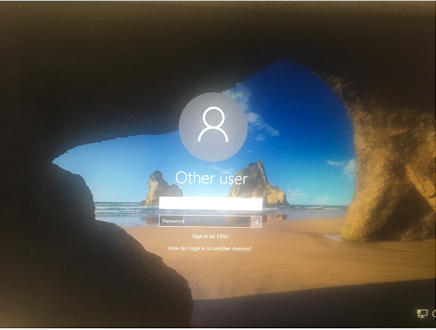

#1 ETSU Network Log In
(computer, email)

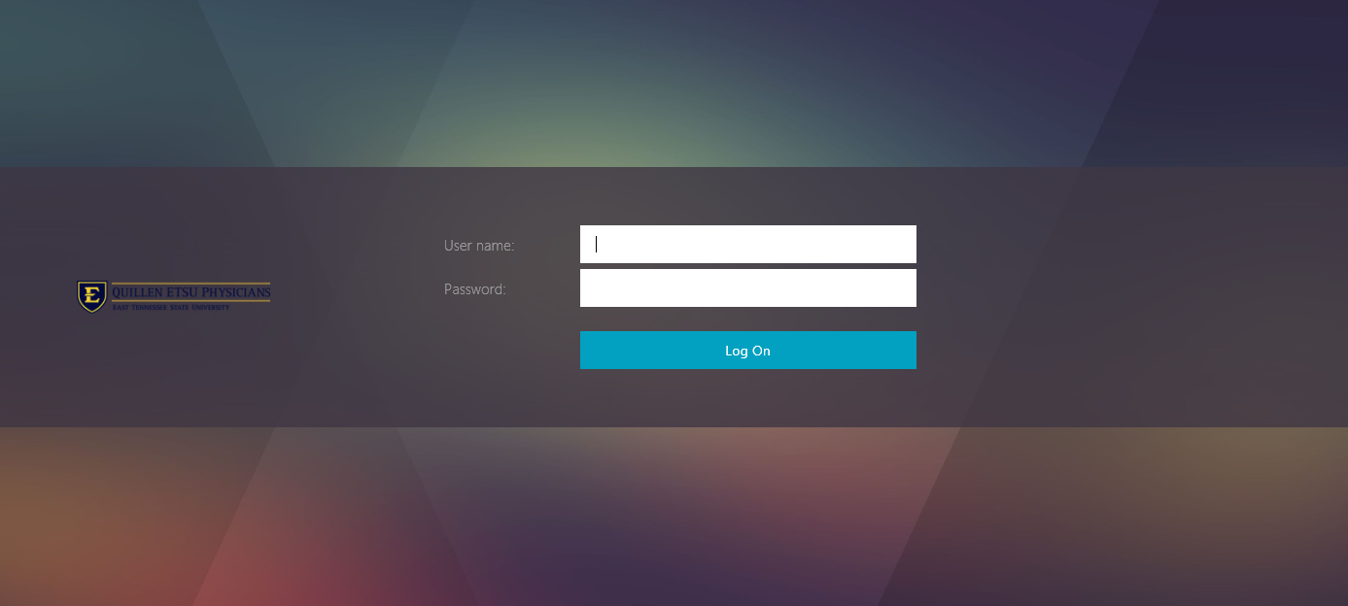

#2 Citrix
(from inside the network)

or #2 Citrix
(outside the network using
login.qetsu.org)

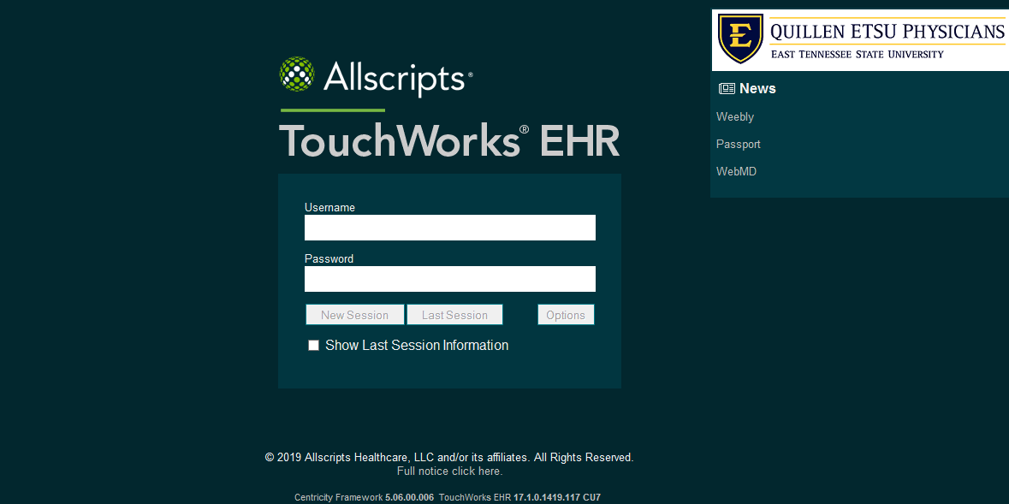

#3 Allscripts

